How to create a pickup:

- Drag any Mesh onto the map
- Add a Sphere Collision and Pickup Component to the Mesh
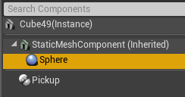
- Resize the Sphere Collision to represent the size of the pickup zone
You’ll now have access to the following variables under the Pickup Component:
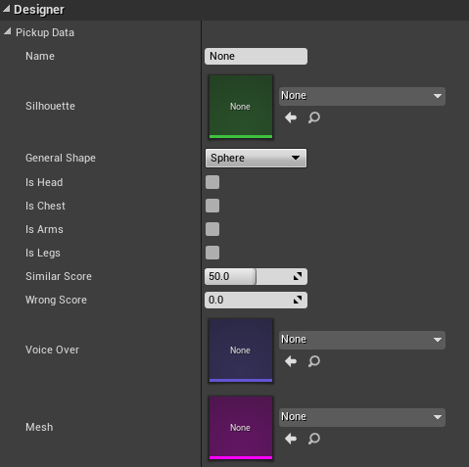
Name: MUST BE UNIQUE for every unique pickup. If two different pickups have the same name this will cause scoring issues.
Silhouette: This image will be used in both the HUD (bottom right hand corner) and the Customiser Screen for the thumbnails. The artists will need to play around with some good dimensions that work. If they need a different image for the HUB and the Customiser screen then this will need to be programmed. Every item must have a Silhouette or expect issues.
General Shape: If players pickup a “similar shaped” object to this one rather than the randomly generated on they’ll gain the points in the similar score.
Is Head, Chest, Arms, Legs: The positions this object can occupy. I recommend only using 1 at a time to not cause mesh issues (artists have designed their meshes for specific positions).
Similar Score: If the player pickups the correct item they’ll get 100% of the points for this position, but if they pickup this item and it is of a similar shape as the desired item, then how many points should they get out of 100?
Wrong Score: If this is selected and doesn’t match anything, how many points should they get out of 100?
Voice Over: Not currently used anywhere
Mesh: Skeletal Mesh that represents the physical appearance of the object.

